Echoes Of Fear

Written by Mango Turtles Studios

Nico

Yoshi

Kameran

Charles

3/30/2018

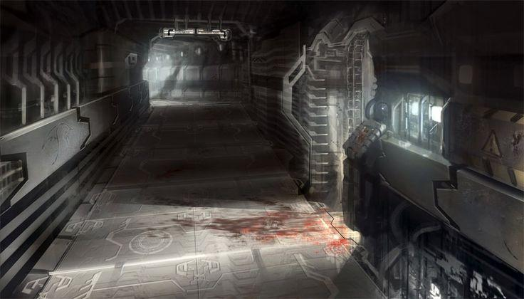

Table of Contents

Echoes Of Fear Document Version History 3

Version 1.0 3

Version 1.1 3

Version 2.0 3

Echoes Of Fear One-Sheet Summary 4

Game Overview 5

Overview of Gameplay 5

Game Goal, Victory Conditions and Loss Conditions 6

Technology 6

Camera 6

Aesthetics 6

o Cut Scenes 6

o Audio 6

o Sound effects 6

o Music 6

o Special effects 6

Story 6

Tier List 6

Player Character(s) 7

Non-player Characters 7

Obstacles 7

Rewards and Collectibles 8

Environment 8

Levels 8

Controls and Controllers 8

First Two Minutes of the Game 8

Sixty Seconds of Game Play 8

Conclusion 8

Appendices 9

# Echoes Of Fear Document Version History

We came up with this idea during our Design 1 class on March 3rd, 2018. Yoshi had the game idea and we were sold from his explanation. From there we made minor changes to the initial idea. For this game, we want to create an atmospheric environment that will keep the player on edge. To do that we created an enemy that is constantly stalking the player. We also created an environment that is claustrophobic and unfamiliar.

## Version 1.0

April 2nd, 2018 is the initial release of the GDD, and the contributors are as followed, Yoshi Kameron, and myself Nico. We are still in pre-production but after conversing with the Programming team we had to slightly change our scope, and to our dismay had to cut out some enemies and features. But we aren’t discouraged and look forward to our next challenges ahead.

## Version 1.1

## Version 2.0

<Etc.>

# Echoes Of Fear One-Sheet Summary

Genre: FPS, Thriller, Survival

**Platform:** PC

**3/29/2018**

**Target Audience**: Mature

**Game Summary**:

In the year 2088, the GenTech conglomerate base of operations Novacore went dark. The entire staff went missing and was never heard from again. The player wakes up in the middle of all the chaos, with a strange item attached to his hand he must escape the facility; however, he is not alone. The player must blast, sneak and blow his way through the facility, while being chased by a relentless creature who will stop at nothing to stop the player from escaping. Can you make it out of the facility in time? Or will you just be another casualty?

Spells/Powers

1. Echoes- creates a decoy of yourself and can act as a distraction, from the enemies
2. Light- it helps light your way in the dark corridors
3. Mine- explosive attack that is activated by pressure
4. Shield- a temporary shield that protects the hero for a short while, depending on the level
5. Light grenade- a projectile grenade that explodes on impact
6. Force- a forceful push attack that can send enemies flying

Enemies

1. Reanimated corpse- slow moving enemies if they get close they can do some real damage.
2. Enity-001B- small bipedal creature that usually attacks in groups, a creation from Entity A
3. Entity-001A- Origin is unknown, the creature is constantly stalking the player

Win/Loss Conditions

1. Get killed by enemies
2. Escape each floor/ escape the facility

# Game Overview

Sometime in the distant future, you wake up wake up in a lab at the bottom of the GenTech conglomerate base. A scientific research base who was on a breakthrough discovery before the base went to hell. You were a recent convict, and instead of the death penalty, Death row inmates get sent to GenTech, where you become test dummies to help advance medicine, and improve modern society. Because of this, the number of convicts that has been given the death row sentence as tripled throughout the years, some might say it's GenTech doing but no one knows for sure. You have been experimented on and given some enhancement bio mechanics, such as biometric eyes, and new experimental bio “link” technology being created for the military. This tech allows you to “link” with a new weapon called “God’s hand” A gauntlet that uses magical energy to cast spells. After seeing the lab is its ruined state you are trying to figure out what happened while trying to escape at the same time.

### Overview of Gameplay

* Each level ends begins and ends the same, find the elevator to the next floor. However, there are twists and turns along the way. Each level is designed to show off the different powers you have obtained through the gauntlet. Solve puzzles and kill the enemies in your way while trying to manage your energy and stay alive.
* We are still unsure; however, the story will be explained through notes left by the former employees on each floor of the game. Not all mysteries will be solved, we will try to fill in the blanks through environmental storytelling
* The theme of this game will be dark and gloomy. We want it to be when you think of the GenTech lab you become uneasy or have shivers.
* I think the hook of the game would be how the player got in there, or why he’s there in the first place, we explained that only death row inmates are the ones who get placed in there, but we did not state the players crime
* Through most of the levels the player would be faced with an unbeatable monster that is stalking the player throughout the game, it is there to keep the tension up and keep the gamers on their toes.

### Game Goal, Victory Conditions and Loss Conditions

The main go of the game is to escape the facility alive, the player would be placed with many obstacles and puzzles, and it is up to you to overcome them to see the light of day again. Death is the only lose condition we have now.

### Technology

We are using a PC to create this game, so the gameplay format is Keyboard and mouse. Headphones are required, this game will be very immersive, so we are trying to capture the theme with eerie sound.

### Camera

This game will be playing in the First-Person point of view

### Aesthetics

futuristic, horror game

### Cut Scenes

will work on later

### Audio

### Sound effects

### Music

### Special effects

Particles, fire, sparks

### Story

The lab has been destroyed by some type of monster like creatures, and you the player after waking up from scientific experiments are now trying to escape the facility, as well as figure out what went on.

### Tier List

Tier 1 Priority 1

**Weapons-**  (Request, keep damage and ammo consumption open)

1. Echoes- sends out a decoy to distract enemies
2. Light- works as a flashlight,
3. Gravity Push- pushes enemies back, does not knock them down.

**Enemies**

1. EIP- slow moving zombie like creatures,
2. Entity 001-A -cannot be killed, need help with the enemy behavior, navigating and reacting when he sees the character.

**Ammo**

1. Energy Cells- works as ammo for all weapons

**Misc**

1. A script for Keys, that unlock doors

Tier two Priority 0 (Don’t need for the game but will be nice)

**Weapons**

1. Lightshot- variation of the flashlight, will do damage to enemies if shined on them
2. Shield- as long as the player has Energy cells he is protected by any enemy or hazardous damage

**Enemies**

1. Entity 001-B -A small spider drone, is actively scanning the area searching for the player, (like a camera) will call Entity A when player is detected

**Misc**

1. Script for a leaver pulling mechanic, (example, pulling a leaver that will activate a small lifting platform)
2. Script for fire, (example, if a pipe has burst in a level, fire will then spout out of the pipe, would work as a stage hazzard.)
3. Script for poison gas, (Example, one are or room will be filled with gas and will slowly give the player damage)

### Player Character(s)

Nameless hero- origins are unknown, all that is known is he was he ended in the GenTech lab because of his past (change if you think of a better idea)

Entity A- is from section 7

### Non-player Characters

Entity 00A- little is known about it. it will kill any living being insight

### Obstacles

The player will use its Gauntlet device to solve simple puzzles like unlocking doors, or luring enemies into certain places.

### Rewards and Collectibles

Notes left behind by the former Lab workers

### Environment

Echoes of Fear will take place in a building.

### Levels

Each level is the player trying to find the next elevator. So, instead of explaining that every time, we will explain the hook of each level instead.

Tutorial- explains basic movement, explanation of the gauntlet

Level 1 Living Quarters- Learns upgrade force push, uses it to solve puzzles

Level 2 Med Bay- learns upgrade decoy, learns more about what happened to the facility

Level 3 Office Space- uses previous two abilities to navigate through the level

Level 4 Escape the base- game finally, player must escape before the base is destroyed and try and trap the main monster.

### Controls and Controllers

Fairly simple controller layout, WASD is to move, while the mouse is used to look around. Scroll the mouse wheel to go through the different weapons, and press E to interact with certain environmental pieces.

### First Two Minutes of the Game

The player wakes up on an operating table, he sees a blueprint next to the table. Unable to comprehend the player has the idea that his body has been modified. He then notices the Gauntlet on his hand and the player has a chance now to mess around with the controls. After the player feels comfortable they can leave the room, and outside the room they encounter the first enemy type. Reanimated Corpse- a slow moving zombie enemy type that is trouble in a big group but is low threat alone. After the player figures out how to defeat the enemy he can now proceed through the rest of the tutorial.

## Sixty Seconds of Game Play

The player is searching for exits while trying to stay alive from the different enemies of the level. Occasionally the player would have to solve puzzles and backtrack to get to the exit.

### Conclusion

In conclusion we are challenging the gamers, seeing if they have what it takes to solve the mystery of what happened, and escape the facility. This is our first attempt at this style of gameplay, and we hope to capture the thrill and emotion that other games in the genre have mastered.

# Appendices

Appendix A

“Appendix A. Maps

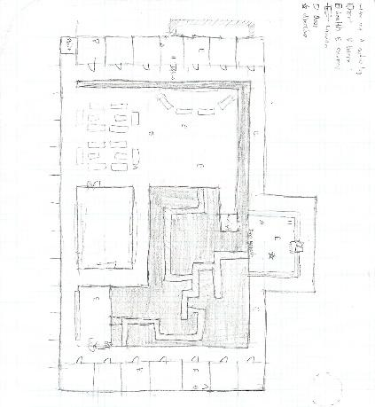

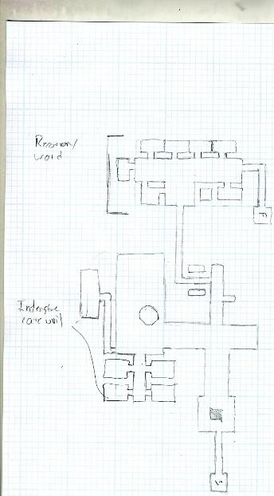

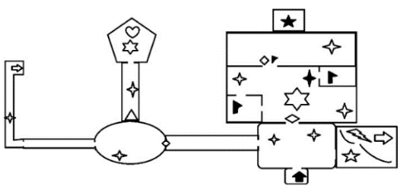

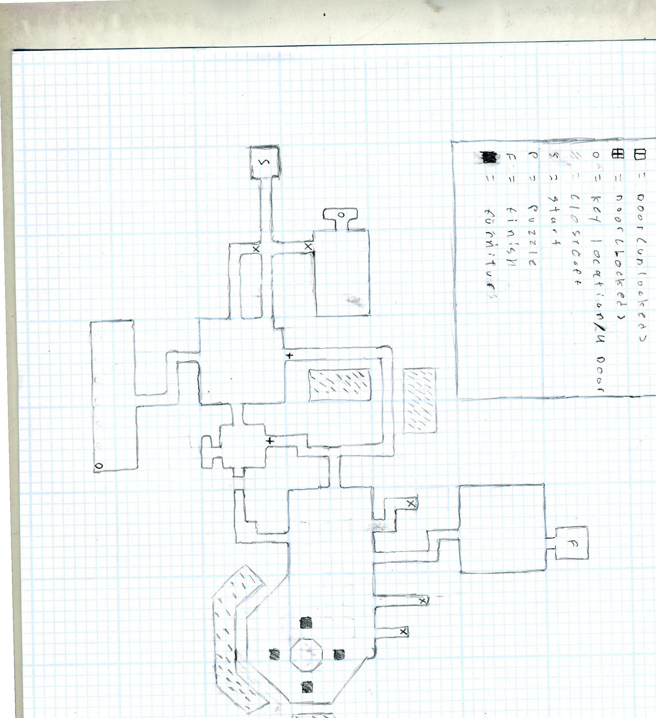

Appendix B. Probability Tables for Rare Spawns

Appendix C. Alternate Universe Character Models” >